

< Solution Name>
Platform Design Document
Version Number: 1.0
Version Date: <mm/dd/yyyy>

Platform Design Document Approval

The undersigned acknowledge that they have reviewed the <Solution Name> Platform Design Document and agree with the information presented within this document. Changes to the Platform Design Document will be coordinated with, and approved by, the undersigned, or their designated representatives.

Signature: |  | Date:
Print Name:
Title:
Role:

Signature: |  | Date:
Print Name:
Title:
Role:

Signature: |  | Date:
Print Name:
Title:
Role:

Revision History

This table records information regarding changes made to the document over time.

Version | Date | Organization/Point of Contact | Description of Changes
1.0 | <mm/dd/yy> | <Organization Identifier / Point-of-Contact Name> | Baseline Version

Table of Contents

1. Introduction 6
2. General Statement of Design 7
3. Platform Architecture and Environment 7
3.1 Hardware, Operating System, Support Software, Network 7
3.2 Impact of system on surrounding environment 8
3.3 Security dependency on other environments 8
4. Network Placement 8
5. Software Deployment 9
6. System Operation Specification 10
6.1 External Interfaces 11
6.2 Performance 11
6.3 Availability 11
6.4 Backup & Restore 11
6.5 Disaster Recovery 11
6.6 Maintainability 11
7. Data 12
7.1 Database management system 12
7.2 Database instances 12
7.3 Data archiving 12
8. Security 12
9. Referenced Documents 13
10. Glossary 13
11. Acronyms 13
12. Appendices 14

List of Figures

Figure 1: Platform Design Context 6
Figure 2: Platform Design 8
Figure 3: Network Diagram 9
Figure 4: Deployment Diagram 10

List of Tables
Table 1: External Interfaces 11
Table 2: Related Database Designs 12
Table 3: Database Instances 12
Table 4: Referenced Documents 13
Table 5: Glossary of Terms 13
Table 6: Acronyms 13

Introduction
[Provide, or reference, a high level description of the computer system. Describe the system in sufficient detail so that its major functions are clearly understood. Include a brief description of the proposed system architecture (e.g., a server-based system, a client-server or multi-tiered architecture or a web-based approach to delivery). Relationships to other systems may be outlined where relevant to the design.]

This document is the aimed to explain how the [Solution Name] is designed and how its components are linked together, and provides enough information for the development of following phases or the project, or the maintenance of the system itself.

The Platform Description Document (PDD) the system design described in the following documents:
- [Solution Name] High-Level Solution Design
- [Solution Name] System Design Document that includes system context diagram

The PDD describes a platform design that meets the requirements specified in the:
- [Solution Name] Requirements Document
- [Solution Name] Database Design Document

[If this document doesn’t stand alone, then include a description and diagram of how it relates to other design documents.]

[Include any diagrams that provide a context for this platform relative to other platform designs.]
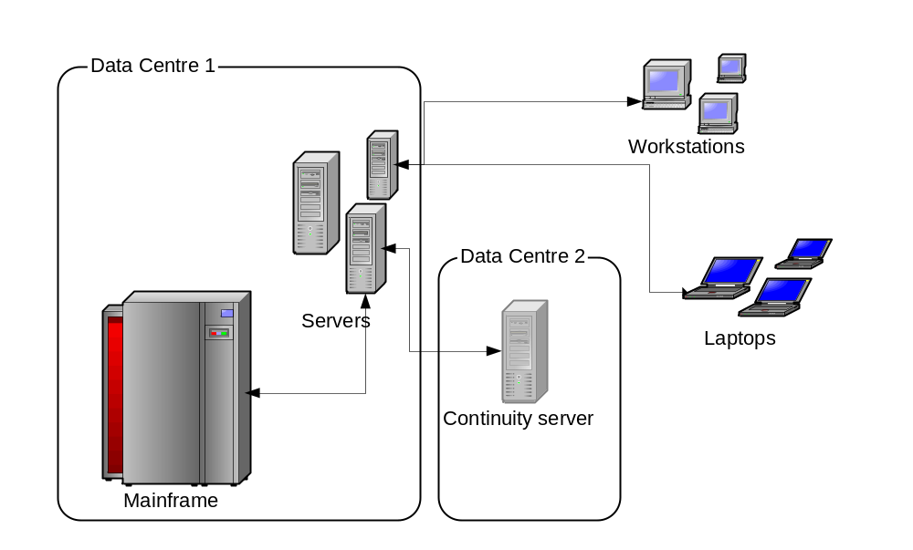
Figure 1: Platform Design Context

General Statement of Design
[Outline the way the computer system is to be designed and to be constructed.
Considerations would include:
- a design methodology and notation
- the planned use of:
  - Computer Assisted Software Engineering (CASE) tools
  - database development tools/schema managers (e.g., Oracle RDBMS for Unix)
  - software development tools and languages (as it may influence design decisions)
- re-use of design templates or software frameworks (with appropriate customisations)
- re-use of existing software components (e.g. executable objects, modules from a code library)
- the means of documenting traceability between design elements and the System Requirements (e.g. a requirements traceability matrix)]

Platform Architecture and Environment

Hardware, Operating System, Support Software, Network
[Provide a description and/or diagram of the breakdown of the required hardware, operating systems, system support software, network and the relationship between them.]
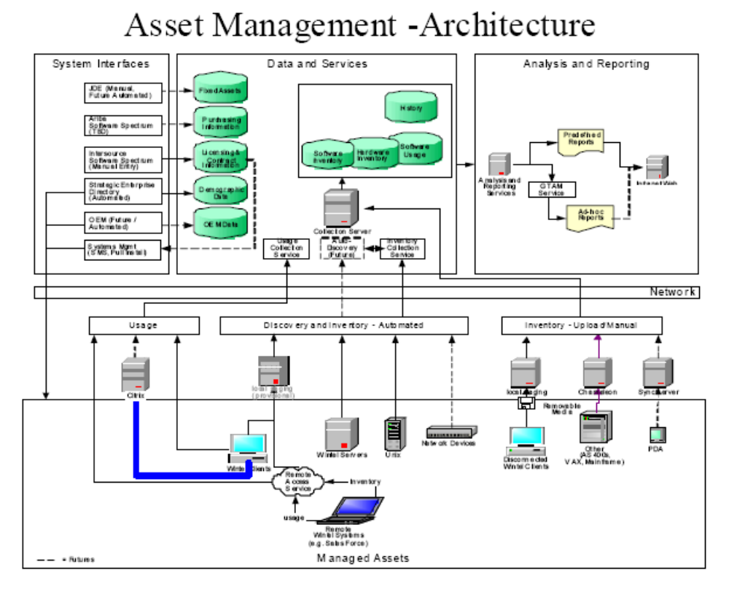
Figure 2: Platform Design

Impact of system on surrounding environment
[Describe any impact on the surrounding environment by this computer system. Include any required changes to working practices, or changes to working capacities for related hardware, networks or other services.]

Security dependency on other environments
[Provide a description of any dependencies upon other system environments where necessary to achieve security control requirements.]

Network Placement
The PDD describes the network view using a network diagram that illustrates the network zones and the placement of the hosts and services within these network zones.
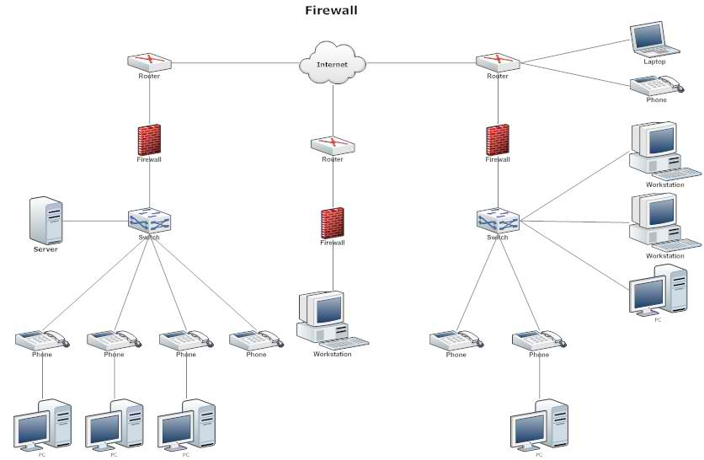
Figure 3: Network Diagram

Software Deployment
The PDD describes the software architecture in a deployment diagram. A deployment diagram models the run-time architecture of a system. It shows the configuration of the hardware elements (nodes) and shows how software elements and artifacts are mapped onto those nodes.

A deployment diagram depicts a static view of the run-time configuration of processing nodes and the components that run on those nodes. In other words, deployment diagrams show the hardware for the system, the software that is installed on that hardware, and the middleware used to connect the disparate machines to one another.

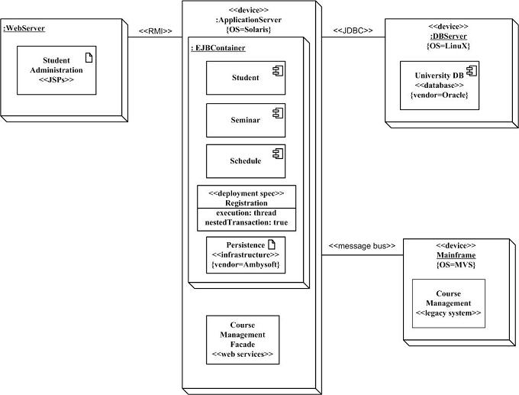
Figure 4: Deployment Diagram

- The three-dimensional boxes represent nodes, either software or hardware.
- Physical nodes should be labeled with the stereotype device, to indicate that it’s a physical device such as a computer or switch.
- Connections between nodes are represented with simple lines, and are assigned stereotypes such as RMI and message bus to indicate the type of connection.
- Nodes can contain other nodes or software artifacts.

System Operation Specification
[For each of the main sections in the System Requirements, a description of how the relevant requirements will be met by the design must be described in the sections below.
Additional topics may include:
- Memory management
- Concurrency/threads
- Portability – does the system have to work on multiple platforms?
- Networking – how will the application provide multi-user access?
- Localization – does it run in multiple locations, how are the differences managed?
- Accessibility – usability of system by people of all abilities and disabilities
- Externalization - consideration for system access via a multitude of user devices, locations and connections.]

External Interfaces
External interfaces are describes at a high-level in the High-Level Solution Design and System Design Document and detailed specifications are included in the Interface Control Document (ICD). This section identifies the interfaces supported by this PDD, provides references to supporting documentation, and describes platform requirements for these interfaces.

[Give a description of how the relevant requirements for interfaces in the “external systems” section of the System Requirements will be met by the design.]

Interface ID | External system | Direction (inbound/ outbound/ both) | Interface Specification | Interface Requirement | Interface Design
 |  |  | [Solution Name] ICD |  | [How platform design meets requirements]
Table 1: External Interfaces

Performance
This section describes how the platform design meets the “performance” requirements within the [Solution Name] Requirements Document.

Availability
This section describes how the platform design meets the “availability” requirements within the [Solution Name] Requirements Document.

Backup & Restore
This section describes how the platform design meets the “backup/restore” requirements within the [Solution Name] Requirements Document.

Disaster Recovery
This section describes how the platform design meets the “disaster recovery” requirements within the [Solution Name] Requirements Document.

Maintainability
This section describes how the platform design meets the “maintainability” requirements within the [Solution Name] Requirements Document.

Data

Database management system
The database management systems are described in the Database Design Document.
Database Name | Database Design Document
Table 2: Related Database Designs
In addition to databases, describe any plain or structured files used to store system data.

Database instances
[Define each instance of the database that is to be used and explain its intended purpose (i.e. development, training, validation and production).]
The following instances are created and used:
Instance name (RDBMS) or path (for file share) | Description | Notes
Table 3: Database Instances

Data archiving
[Explain any plans or schedules for data archiving. Include a description of the data archiving facilities.]

Security
[Use diagrams and/or text to describe the security mechanisms that will be used to meet the relevant security requirements, to include:
- Identity Management (user administration)
- Access Control (authentication/authorization)
- Security Event Logging (login activity)
- Input Validation (data validation)
- Session Management
- Cryptography (encryption/decryption, hashes)
- Secure Database Connectivity
Where technically possible, externalize access control and other security mechanisms to underlying infrastructure components rather than code application-specific logic. For authorization, re-use security groups that are defined and managed externally to the application wherever feasible, limiting business logic to enforcement of functional access rules in accordance with defined business rules.
Identify how compliance with security controls defined in applicable polices, procedures and standards (e.g. Web Development standards) is addressed based on the type of application and Application Risk level.]

Referenced Documents
Table 4: Referenced Documents lists all documents used to arrive at and/or referenced within this document (e.g., related and/or companion documents, prerequisite documents, relevant technical documentation, etc.).

Document Name | Issuance Date
Electronic and Information Technology Accessibility Standards (Section 508) | December 21, 2000
<System Name> High-Level Solution Design | <Month Day, Year>
<System Name> Requirements Document | <Month Day, Year>
Table 4: Referenced Documents

Glossary
Table 5: Glossary of Terms provides clear and concise definitions for terms used in this document that may be unfamiliar to readers of the document.

Glossary Term | Definition
Table 5: Glossary of Terms

Acronyms
This section provides a list of acronyms and associated literal translations used within the document.
Acronym | Literal Translation
MYORG | California Correctional Health Care Services
COTS | Commercial Off-the-Shelf
DBMS | Database Management System
DDD | Database Design Document
ICD | Interface Control Document
LAN | Local Area Network
SDD | System Design Document
WAN | Wide Area Network
Table 6: Acronyms

Appendices
[Utilize appendices to facilitate ease of use and maintenance of the PDD document. Each appendix should be referenced in the main body of the document where that information would normally have been provided. Suggested appendices include (but are not limited to):
- Requirements Traceability Matrix – demonstrate backward traceability of the system and software architectural designs to the functional and nonfunctional requirements documented in the Requirements Document.
- Section 508 Product Assessment – demonstrate compliance or non-compliance with accessibility standards provided in Section 508 of the Rehabilitation Act of 1973, as amended effective June 20, 2001.

